Testing plan: Coursework 17/18 step 1

Designed and executed by B00329768 Mikolaj Lukasik on 12/04/2018.

Table of Contents

1. JSON file creation 2

2. JSON file content 2

3. Serial number generation for batches 2

4. Serial number generation for components 3

5. Serial number storage in JSON 3

6. Main menu navigation 4

7. New batch component numbers input control 5

8. Selecting product type 6

9. Selecting product subtype 7

10. New batch presentation 8

# JSON file creation

## Expected result:

Simply starting the program should result in creation of a new BatchIndex.json file in Data folder.

## Actual result:

File created.

## Screenshots:

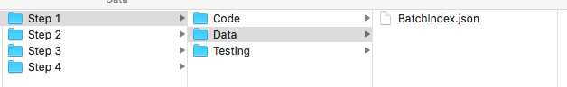

# JSON file content

## Expected result:

BatchIndex.json file on creation should represent an empty list.

## Actual result:

File created correctly.

## Screenshots:

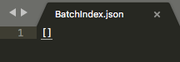

# Serial number generation for batches

## Expected result:

Program should generate batch serial numbers based on manufacture date in format DDMMYYXXXX where DDMMYY is the date of manufacture and XXXX is a unique sequential number between 0001 and 9999. The sequential numbers should start from 0001 on a new manufacture date.

## Actual result:

Batch numbers are generated properly on an empty batches database (ss1), with batches already existing for current day (ss2), and after date changes to new day(ss3).

## Screenshots:







## Disclaimer:

This was tested by temporarily changing the system date.

# Serial number generation for components

## Expected result:

Program should generate sequential serial number for each individual component in the form DDMMYYXXXX-AAAA where DDMMYYXXXX is the batch number and AAAA is the unique sequential component number in the range 0001 to 9999.

## Actual result:

Components serial numbers are generated properly up to 9999.

## Screenshots:

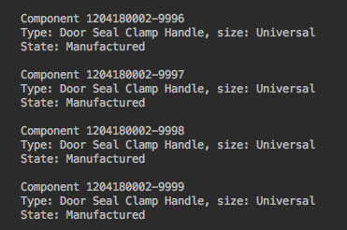

# Serial number storage in JSON

## Expected result:

After creation of a batch, its number is stored as a string in a list saved in BatchIndex.json file.

## Actual result:

BatchIndex.json properly stores batch numbers.

## Screenshots:



# Main menu navigation

## Expected result:

Main menu allows only numbers presented before the menu options. If any other input is provided, it will show error message.

## Actual result:

When provided with 1 (ss1), program moves on to creating a new batch. 2 exits the program. Any other alphanumeric or multisymbolic input (ss3, ss4) shows an error message.

## Screenshots:

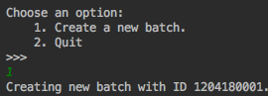

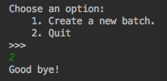

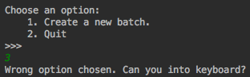

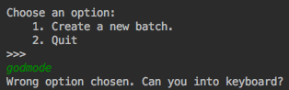

# New batch component numbers input control

## Expected result:

Selecting proper number of component in the batch (1-9999) will let user continue into the program and select the type of component to make.

## Actual result:

Program accepts natural numeric input from 1 up to 9999 (ss1, ss2) and let user go through to next step. It will not accept any other alphanumeric or multisymbolic (ss3) input and shows an error message.

## Found bug:

Program displays the wrong number of acceptable components (0-9999) but won’t let the user through when they provide 0 as a number of component to make (ss4). This will be fixed in next versions.

## Screenshots:

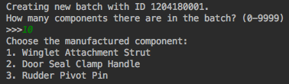

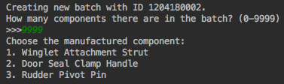

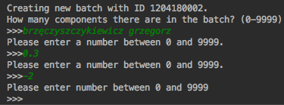

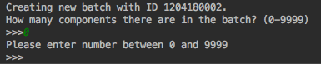

# Selecting product type

## Expected result

The program allows to choose a number from list of products. If the number is provided correctly, program goes on to selecting subtype.

## Actual result

If the user inputs correct number, program lets user onto selecting subtype (ss1, ss2). User can also write X or x to cancel (ss3). Any other alphanumeric or multisymbolic (ss4) input will not be accepted – program will display the selection again.

## Bugs found

Universal product is bypassing the confirmation dialog straight to new batch presentation (ss5).

## Screenshots

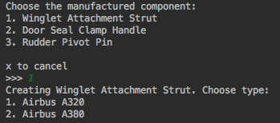

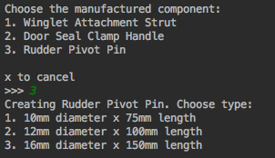

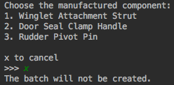

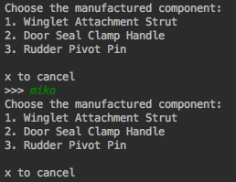

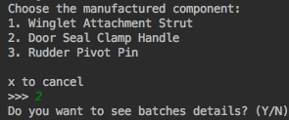

# Selecting product subtype

## Expected result

User will select the correct product subtype and go on to confirming batch details.

## Actual result

User can select proper subtype or X to go back to main menu without creating anything. If they choose to input anything else than provided options, it will result in an error message, and the selection will go back to product type stage.

## Screenshots

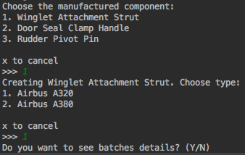

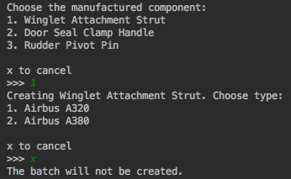

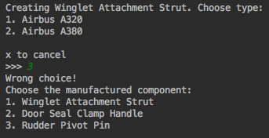

# New batch presentation

## Expected result

After a batch creation user can select to present its contents.

## Actual result

User can select Y or y to show detailed view of the batch and its components (ss1). After the presentation program goes back to main menu. Any other input will get the program back to main menu (ss2, ss3).

## Screenshots

